**EXPERIMENT 5**

**Aim:** if-else statement in bash.

**Statement 1:**

#!/bin/bash

if [ 1 -eq 1 ];

then

echo "1 is equal to 1"

fi

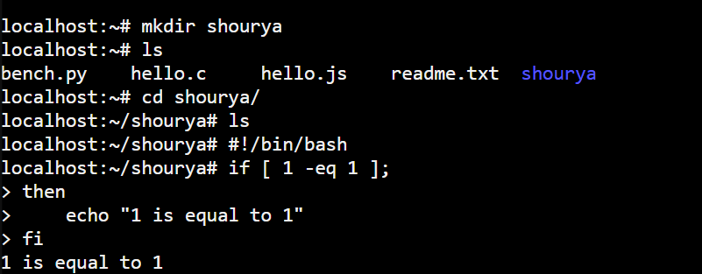

**Statement 2:**

#!/bin/bash

if [ 1 -eq 1 ];

then

echo "1 is equal to 1"

else

echo "The numbers are not equal"

fi

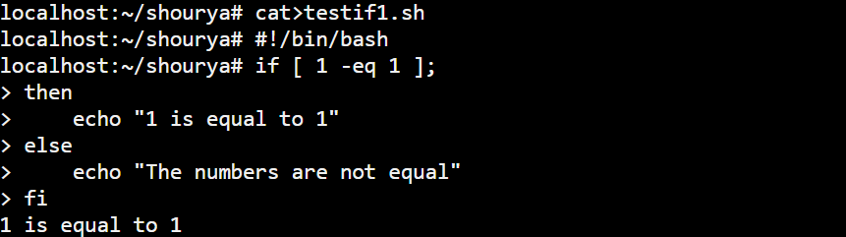

**Statement 3:**

#!/bin/bash

if [ -f data.txt ]

then

echo "File exists"

else

touch data.txt

echo "New file created"

fi

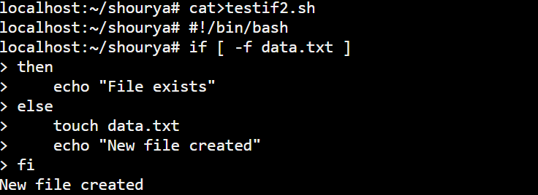

**Statement 4:**

#!/bin/bash

user="admin"

if [ "$user" = "administrator" ];

then

echo "The string matches"

else

echo "The strings do not match"

fi

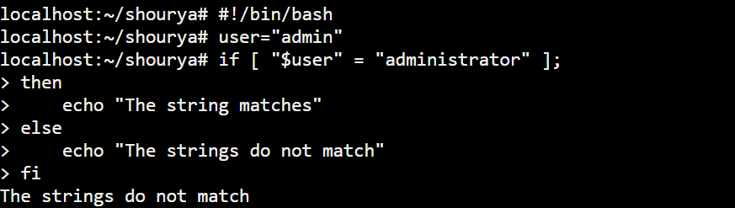

**Statement 5:**

#!/bin/bash

auth_users="admin"

read -p "What's your name? " user

if [[ "$user" == "$auth_users" ]];

then

echo "You are an administrator"

elif [[ -z "$user" ]];

then

echo "Please enter a username"

read user

echo "Hello $user, Greetings!"

else

echo "You are a standard user"

fi

